

ADDIS ABABA UNIVERSITY

ADDIS ABABA INSTITUTE OF TECHNOLOGY

CENTER OF INFORMATION TECHNOLOGY AND

SCIENTIFIC COMPUTING

Internet History and Websites

Prepared By**:** Hailemariam Fikadie

February 2020

Contents

History of Internet 1

Most Popular Websites Assessment on Web Archive 2

Instagram 2

Amazon 5

Twitter 7

YouTube 9

W3school 11

Categories of websites 13

Educational website 13

News Website 14

Social Network 14

Personal website 14

Portal Websites 15

Business/Marketing Websites 15

Blog Websites 16

Informational Websites 16

Entertainment Websites 17

Wiki Websites 17

Advocacy Website 18

Content Aggregator 18

Website evaluation guideline 19

Authority 19

Purpose 19

Objectivity 19

Accuracy 19

Reference 19

List of Figures

Figure 1 Instagram in 2011 2

Figure 2 Instagram in 2012 3

Figure 3 Instagram in 2013 4

Figure 4 Instagram in 2018 and 2019 5

Figure 5 Amazon in 2013 6

Figure 6 Amazon in 2018 7

Figure 7 Twitter in 2012 8

Figure 8 Twitter in 2018 9

Figure 9 YouTube in 2012 10

Figure 10 YouTube in 2018 11

Figure 11 W3school in 2010 12

Figure 12 W3school in 2018 and 2019 13

# History of Internet

Internet is the largest wide area network, since it’s a massive network of network. It is the infrastructure that allow connect billions of computers and other electronic devices, and it’s an increasingly important part of everyday life for people around the world. The internet has revolutionized the computer and communications world like nothing before.

In the early days of computing technology, computers were seen as a device for making calculations and to store data’s and they were used to accelerate business process. However as the technological advancement increase (computing device increase) it leads to for the invention of Internet to connect one computing device to the other.

The first workable prototype of the internet came in the late 1960’s with the creation of ARPANET (Advanced Research Projects Agency Network. Originally funded by the U.S Department of Defense. ARPANET used packet switching to allow multiple computers to communicate on a single network. On October 1969 ARPANET delivered its first message from one computer to another which is “a node to node” communication. Even though there is a communication between them, the first message wasn’t set successfully to destination, only the first two letters delivered.

The technology continued grow, In the 1970’s Robert Kahn and Vinton Cerf developed Transmission control protocol (TCP) and Internet protocol (IP) , which is a communication model that set a standards for how data could be transmitted between multiple networks.

The online world took a more recognizable form when Tim Berners-Lee invented the World Wide Web. The web helped popularized the internet across the globe.

# Most Popular Websites Assessment on Web Archive

## Instagram

Instagram is a free social networking application which purpose is to share pictures, videos, or it is a simple way to capture and share the world’s moments. Follow your friends and family to see what they’re up to, and discover accounts from all over the world that are sharing things you love. Well, now let’s see my observation on web archive in different year. In 2011 it was looks like as follow:

* It contain some images and texts
* There is no direct log in form when it was open. instead its log in page was appear after clicking an edit account link
* The mobile phone 3d picture that appear in the left of webpage contain an image what it looks like when it opened in actual mobile phone.
* There was a like that will delivered AppStore page to download Instagram application.
* At the bottom of the page there were some likes like contact us, blog etc.

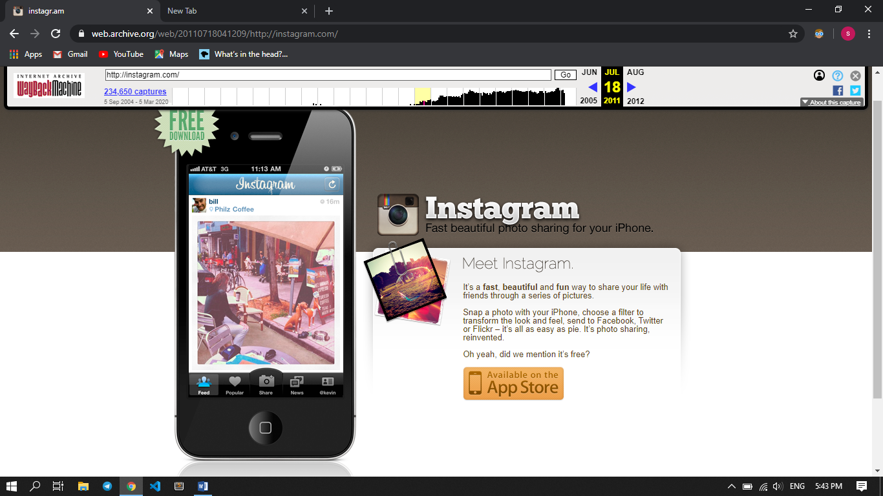

Figure Instagram in 2011

Let’s see what looks like in 2012:

* The mobile phone now contain a normal slide show that shows What it looks like when the user navigate through the app icons, and also add additional like for downloading the app, like google play
* The background and the bottom navigation now looks good.
* The login page appear as like in 2011.

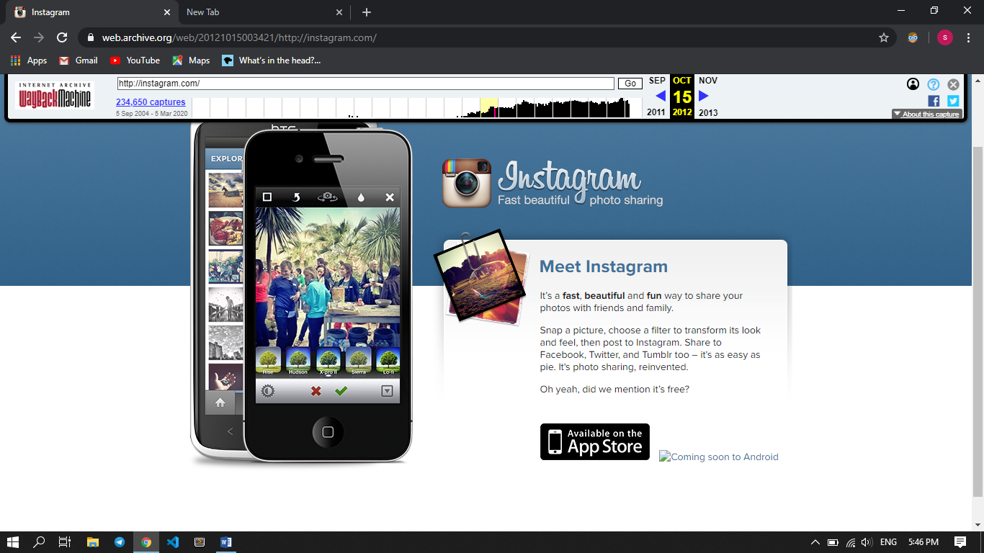

Figure Instagram in 2012

In 2013 it was looks like as follow:

* It looks like just in 2012 but , the log in like contain an Icon and now , the user can get full info about Log in page, since it say’s Log In.

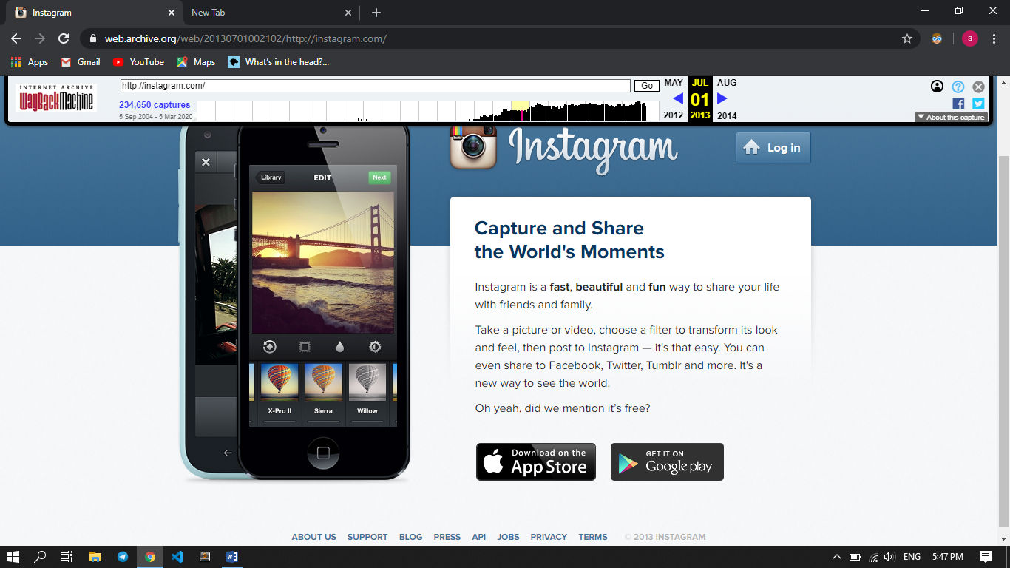

Figure Instagram in 2013

In 2018 and 2019 it was looks like as follow:

* When it was open the Instagram, it was though progress by its icon
* It looks very nice and contain best log in page with different option like, login with Facebook and best animation on the mobile phone appear in the left of the page.

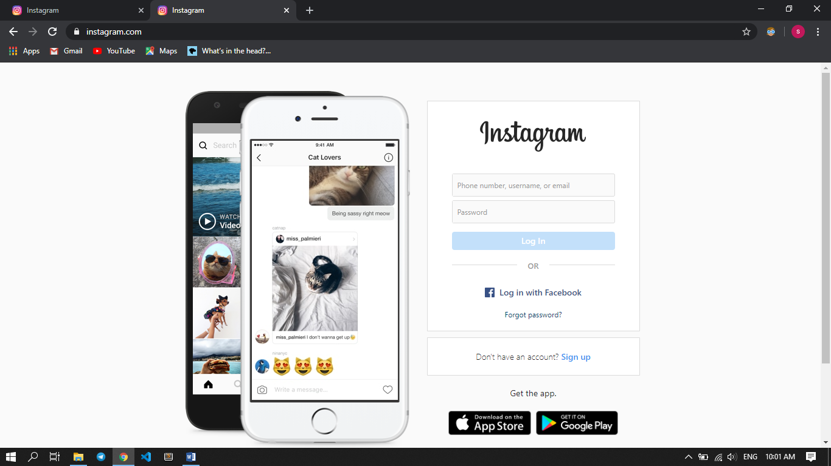

Figure Instagram in 2018 and 2019

In conclusion, as the time increase the website effect or its look become very nice.

## Amazon

Amazon is one of the largest e-commerce site in the world that provide almost everything in the current market, and also they give different service like for storing large amount of data. Now let’s look what looks like in 2018 and 2013 from web archive, since almost all other years have the same view or structure.

Some observation in 2013 from web archive

* When it was seen, it seems made by just anchor tags, list, images and some additional features like search bar etc.. this mean it almost done by HTML(hypertext markup language) and CSS(cascading style sheet)
* Divide available products in logically and put it in grid manner
* In the right part of the page there is some features like best sellers

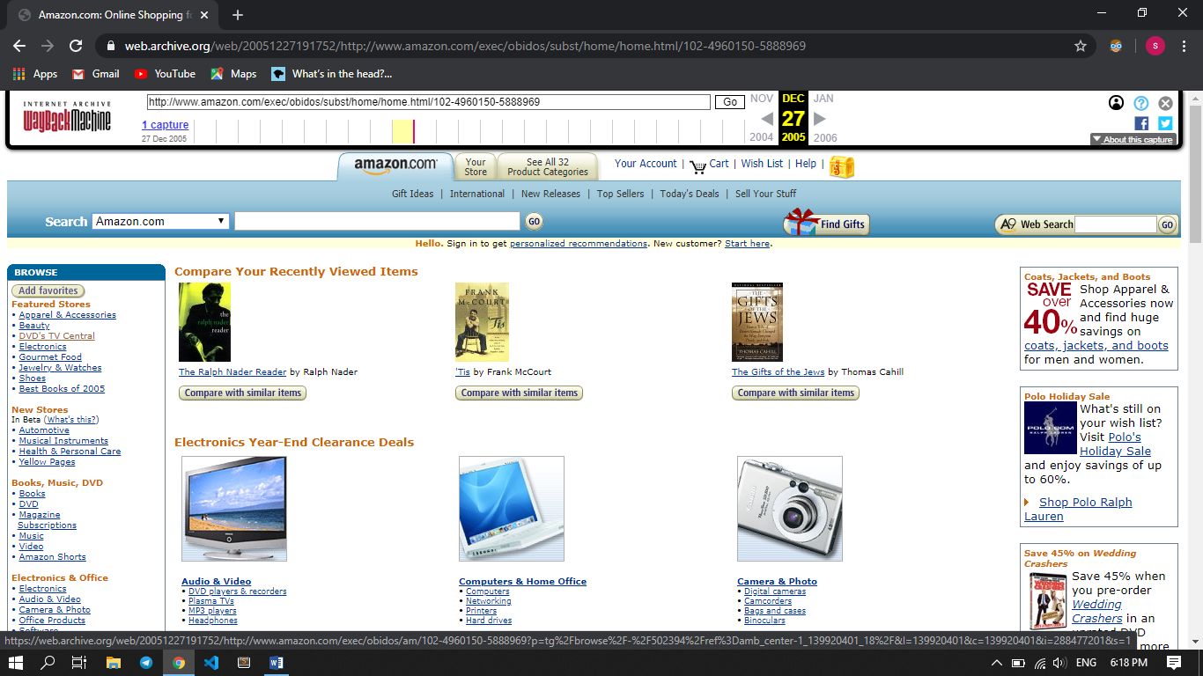

Figure Amazon in 2013

In 2018 it was looks like as follow

* In this year the navigation bar was very cool as compared to the previous years.
* Menu items were put in customized manner
* Image quality was very high
* They put products by grouping with in different categories, and within each categories each item has visible price and like for more additional information regarding the item
* There were a slide show in each categories for showing all available items.
* There were back to top button which is a java script feature for scrolling the page to the top part of the page.
* The bottom navigation is the same as it was in the previous
* Near to the search bar there is a spinner for selecting searching item, it was small in the previous year now it have more than 50 categories.
* It support different language
* There is an option for sign up and sign for amazon account
* The colors they choose for the page is attractive

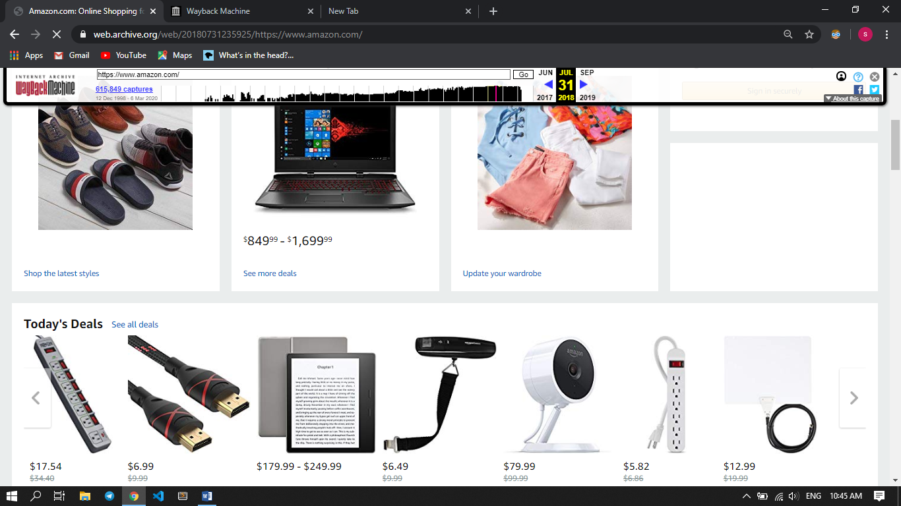

Figure Amazon in 2018

## Twitter

Twitter, a social networking site launched in 2006, is undoubtedly one of the most popular social media platforms available today, with 100 million daily active users and 500 million tweets sent daily. It can be used to receive news, follow high-profile celebrities, or stay in-touch with old high school friends. Let’s see what looks like in different year from web archive.

Some observation for 2012 version

* There is one background color
* One image that describe about well come greeting
* There were two forms for sign in and sign up
* There were bottom navigation for about, help, blogs….. pages
* It was not attractive when the user seen it.

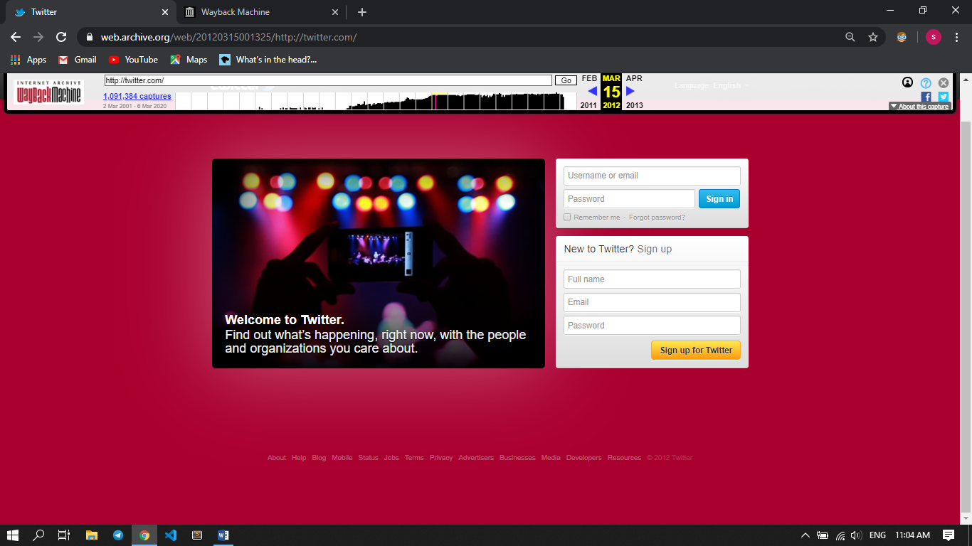

Figure Twitter in 2012

In 2018 it was looks like as follow

* The page was divided in two parts one for sign in and sign up one for some additional features which is added recently in their page like join conversation, follow your interest.
* In the previous version user can only sign in by email , username now user can log in by phone number
* When it compared to the previous years now, its look become good, but that much not enough for attracting users
* The bottom navigation still there by adding some features like setting, marketing and business.

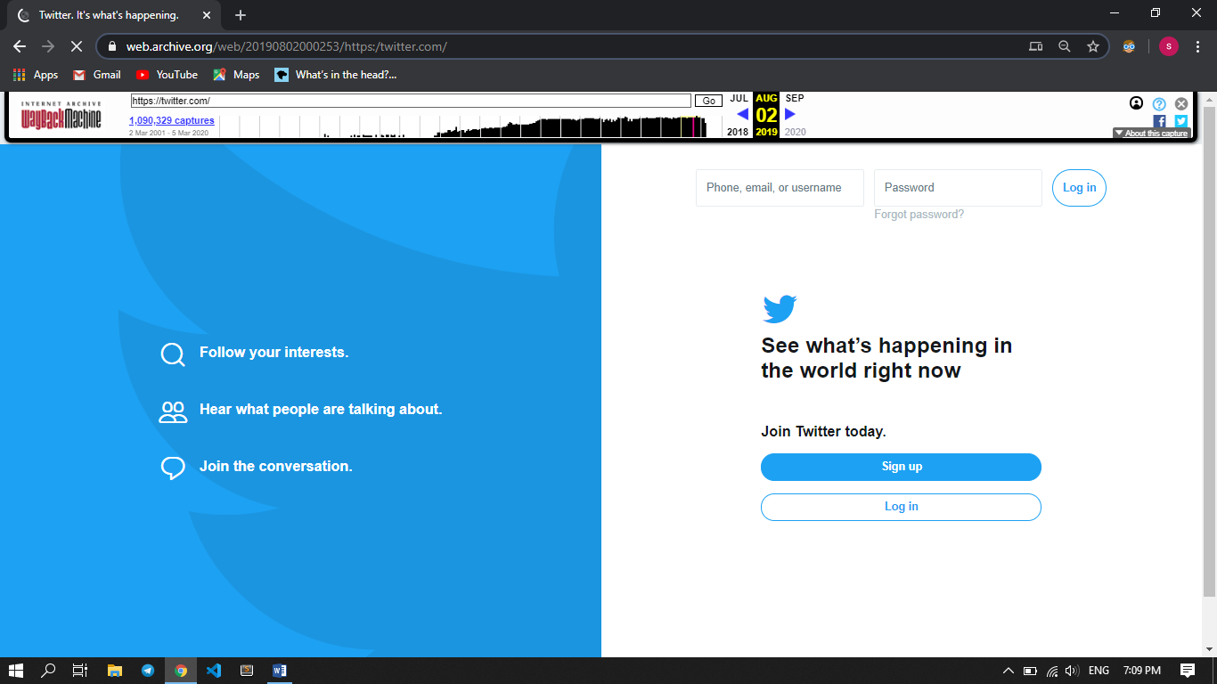

Figure Twitter in 2018

## YouTube

YouTube is the most popular video sharing and the second largest search engine behind google search engine. Billions of videos have been uploaded and shared on the platform since it was founded in 2005, ranging from Hollywood movie trailers and music videos, to amateur vlogs (Video blogs) and videos of cats. Now I well show you what looks like in different years from web archive.

Some observation in 2012

* There were very high margin from both side right and left.
* Features in the which is the left part of the page not seen properly, since the background was black and the text color is gray
* Some video images is not seen
* The search bar and the videos are far apart and when the user type something in the search bar only display what the user type.
* It contain some additional features like Help and Language

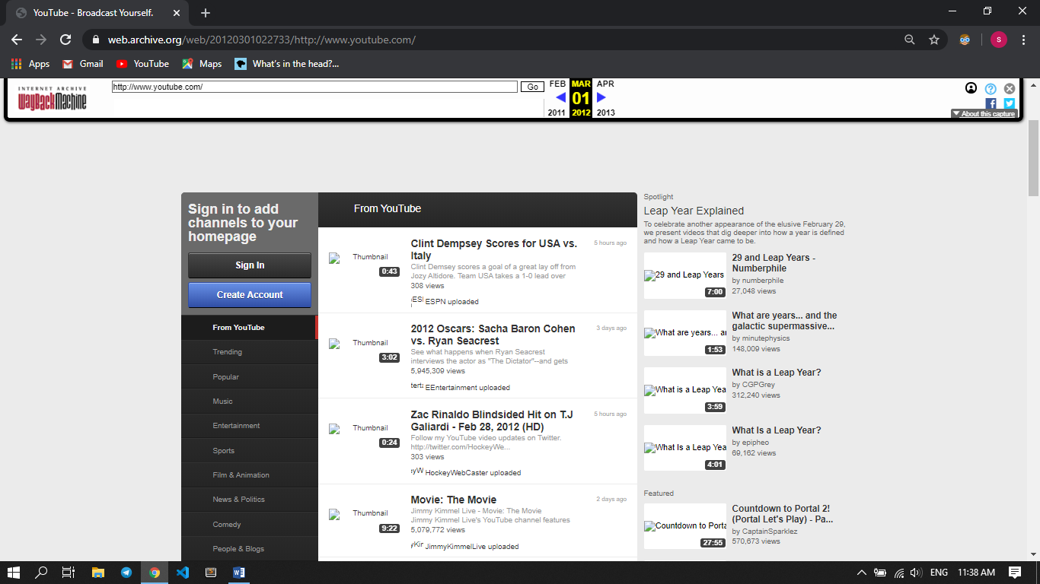

Figure YouTube in 2012

In 2018 it was looks like as follow

* In this year the available videos arranged in grid manner and looks good.
* The styling of background and text colors not it’s attractive
* Image quality was high
* The way they put the information about each videos like View, length and title was changed. In the previous they was taken many space and put it into many categories. But now they arrange every information in one box and in a very good style.
* In this year the used almost all area of the page with some margin
* Some feature like TV shows ,spot light features were added

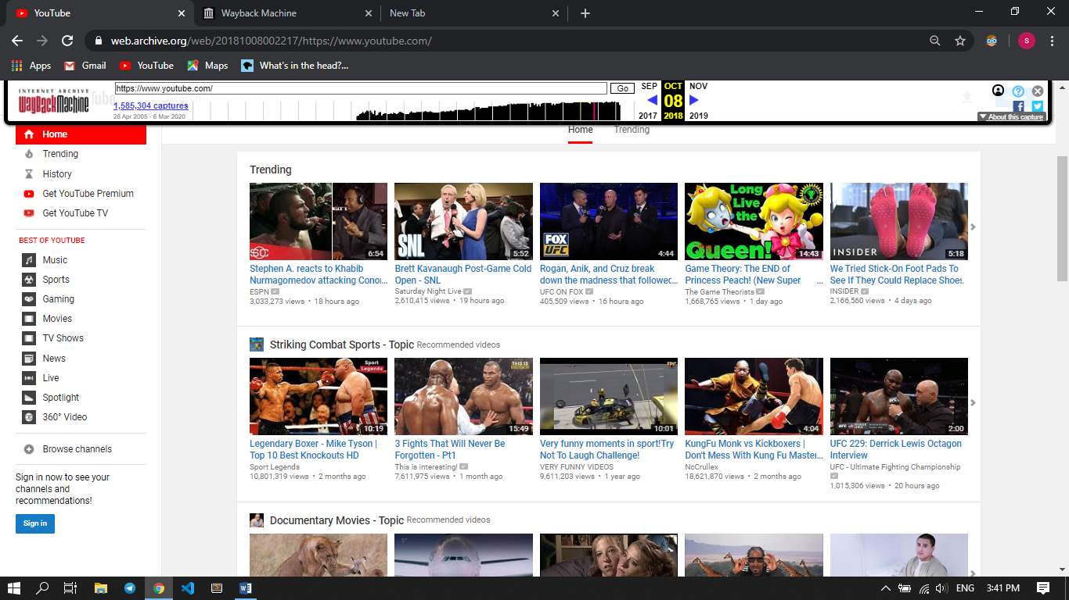

Figure YouTube in 2018

## W3school

W3Schools is a web developers site, with tutorials and references on web development languages such as HTML, CSS, JavaScript, PHP, SQL, Python, jQuery, Java, C++, C#, React, XML, W3.CSS, and Bootstrap, covering most aspects of web programming.

Let’s look what some observation regarding this educational website.

In 2010 it was looks like as follow

* There is margin in left and right part of the page
* They were trying to categorize different tutorials
* It looks bad, since it is without background
* There was Try it yourself feature for simple editor in the home page not in each tutorials.
* It support many tutorials this shows that its popularity
* It have a search engine for searching tutorials, examples….
* The title motivate the readers, it was say “EDUCATE YOUR SELF!”

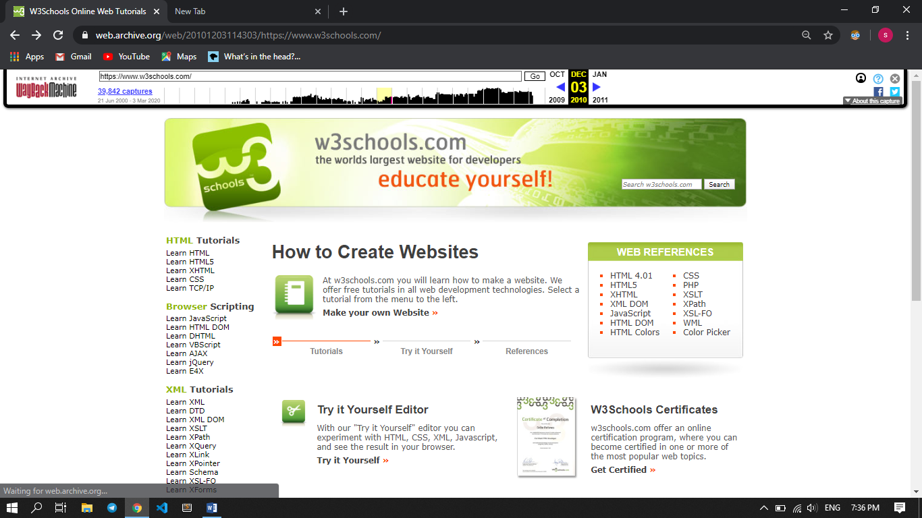

Figure W3school in 2010

Some observation and changes in 2018

* Try it yourself feature, now it’s in side each tutorials, this allows the reader can exercise alongside reading the tutorials
* The text color and background now looks good
* They introduce fixed navigation bar and **How to** examples which is the most interesting part of w3school tutorials, it allow do many important examples which is seen in many websites
* They add scroll bar in the left navigation since the content increase
* Best search engine which is the feature of JavaScript
* Two navigation top and left which allow us navigate as we want
* Every content in each tutorials is up-to-date
* They were add some programming language like C, C#......

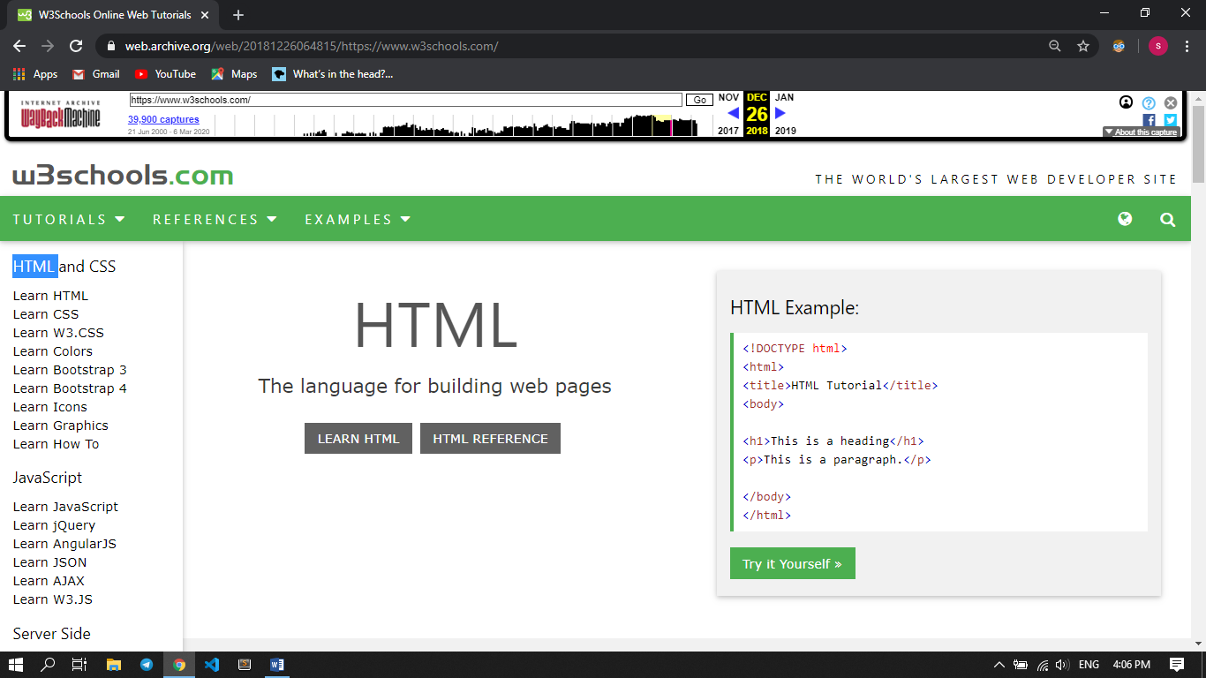

Figure W3school in 2018 and 2019

# Categories of websites

## Educational website

Those websites have videos, topic related resources that act as tools to enhance learning and supplement class room teaching process.

Example:

Name URL

* Coursera <https://www.coursera.org/>
* Stack over flow ` <https://stackoverflow.com/>
* Quora <https://www.quora.com/>
* Udemy <https://www.udemy.com/>
* Udacity <https://www.udacity.com/>

## News Website

In those type of websites delivered different types of news on each type for online users across the world through their website.

Example:

Name URL

* ABC news <https://abcnews.go.com/>
* The Guardian <https://www.theguardian.com/>
* Forbes <https://www.forbes.com/>
* Hollywood reporter <https://www.hollywoodreporter.com/>
* Daily sun <https://www.dailysun.co.za/>

## Social Network

It’s the use of internet based social media websites to stay connected with friends , family , colleagues etc… and also it used for mainly sharing different videos , files , and pictures , while some others for searching jobs.

Example:

Name URL

* LinkedIn <https://www.linkedin.com/>
* Instagram <https://www.instagram.com/>
* Tik Tok <https://www.tiktok.com/en/>
* Skype <https://www.skype.com/en/>
* Twitter <https://twitter.com/>

## Personal website

Personal website: This website basically used for describe personal information simply as Curriculum vitae. And also sometimes used to promote something for business activity.

Example:

Name URL

* Anthony Wiktor <https://www.anthonydesigner.com/>
* Gary Sheng <http://www.garysheng.com/>
* Tony D <http://tonydorio.com/>
* Gray <https://www.cgpgrey.com/>
* Grant <http://grantbaldwin.com/>

## Portal Websites

Web Portals represents websites that bring many web resources together and offer forums, emails, search engines, etc. They are also used as an internal tool at universities or companies as they are perfect for keeping all important information in one place.

Example:

Name URL

* AAU <https://portal.aau.edu.et/>
* UAB patient portal <https://www.uabmedicine.org/>
* Marines <https://www.marines.com/>
* Stanford university <https://axess.sahr.stanford.edu/>
* AutoZone <https://www.autozone.com/>

## Business/Marketing Websites

Business/Marketing: In those sites offering goods and services sale and enabling online transactions for such sales, or by selling advertisement, even simply by providing any service that generate a revenue or cash flow.

Example:

Name URL

* eBay <https://play.google.com/>
* Fiverr <https://www.fiverr.com/>
* Like2Buy <https://www.curalate.com/>
* Pinterest <https://business.pinterest.com/>
* Alibaba <https://www.alibaba.com/>

## Blog Websites

This website provide platform like, to share your experience and knowledge with internet users. On the internet, and also, it’s like an online personality prototype of the owner of the blog.

Example:

Name URL

* Blogger <https://www.blogger.com/>
* WordPress <https://wordpress.com/>
* Tumblr <https://www.tumblr.com/>
* Weebly <https://www.weebly.com/>
* Blogster <http://www.www.blogster.com/>

## Informational Websites

This website offer known facts, statics for different event that happened in the world, ideas regarding about the current, even for the future and more… sometimes those websites provide a procedure for a certain work that we want.

Example:

Name URL

* Information is beautiful <https://informationisbeautiful.net/>
* How staff works <https://www.howstuffworks.com/>
* Cooking for Engineers <http://www.cookingforengineers.com/>
* Mind Tools <https://www.mindtools.com/>
* Mashable <https://mashable.com/>

## Entertainment Websites

These websites showcase entertaining information for visitors. Online magazines, gossip oriented websites, celebrity news, sports coverage, movies, the arts, humorous websites, etc. These websites are designed to be easy to navigate and frequently updated in order to keep users coming back for more information. They can be made more engaging by using dynamic content, such as videos, podcasts, slideshows, etc.

Example:

Name URL

* Eonline <https://www.eonline.com/ap>
* just for fun <https://9gag.com/>
* Netflix <https://www.netflix.com/et/>
* Imdb <https://www.imdb.com/>
* YouTube <https://www.youtube.com/>

## Wiki Websites

Wiki is a type of website, it’s website content area, or the software used to operate and maintain it, where users of the site can collaboratively edit, structure, and provide new content for the site. This is in contrast to most types of websites, which only show content provided by the website’s operators, or may allow each user to provide content that only its author can edit.

Example:

Name URL

* Wiki books <https://en.wikibooks.org/wiki/Main_Page>
* Wikipedia <https://www.wikipedia.org/>
* Gamepedia <https://www.gamepedia.com/>
* Strangerthings <https://strangerthings.fandom.com/>
* Bassbell reference <https://www.baseball-reference.com/>

## Advocacy Website

An Advocacy website is a website that people make to try get people to see their opinion on certain subjects. Or it’s an activity by an individual or group that aims to influence decisions within political, economic, social systems, institutions. Advocacy includes activities and publications to influence public policy, laws and budgets by using facts, their relationships, the media, and messaging to educate government officials and the public.

Example:

Name URL

* Speak out <https://www.speakoutnow.org/>
* Asista <https://asistahelp.org/>
* Change <https://www.change.org/>
* Alliance <https://www.afj.org/>
* Human right campaign <https://www.hrc.org/>

## Content Aggregator

It is a site that collects pieces of content, such as blog articles, photos or videos, all in one place so that users can find them more easily. Some aggregators are niche sites that collect content for specific purposes. For example, News aggregator websites allow users to view news and updates from various sources at one convenient location.

Example:

Name URL

* Rottentomattoes <https://www.rottentomatoes.com/>
* Reddit <https://www.reddit.com/>
* Apple news <https://www.apple.com/apple-news/>
* [Epicurious](https://www.epicurious.com/) <https://www.epicurious.com/>
* Google news <https://news.google.com/?hl=en-ET&gl=ET&ceid=ET:en>

# Website evaluation guideline

  A website is well presented does not mean that it contains accurate information, or it’s almost good for everything which is asked by either SEO (search engine optimization) or personal view. There for in order to be good there is some criteria. Those are presented below

## Authority

Authority reveals that the person, institution or agency responsible for a site has the qualifications and knowledge to do so

## Purpose

The purpose of the information presented in the site should be clear. Some sites are meant to inform, persuade, state an opinion, entertain, or parody something or someone

## Objectivity

Objectivity of the site should be clear. Beware of sites that contain bias or do not admit its bias freely. Objective sites present information with a minimum of bias

## Accuracy

There are few standards to verify the accuracy of information on the web. It is the responsibility of the reader to assess the information presented.

# Reference

* https://www.theguardian.com/international/
* https://edu.gcfglobal.org/
* https://www.webopedia.com/
* https://www.history.com/
* https://www.forbes.com/
* https://youtu.be/2Uj1A9AguFs
* https://www.quora.com/
* https://liferay.dev/
* https://ecommerceguide.com/
* https://www.introtodigital.com/tag/content-aggregator-tools/
* https://blog.hubspot.com/
* https://www.w3schools.com/about/
* https://www.lifewire.com/
* https://cdn.dal.ca/